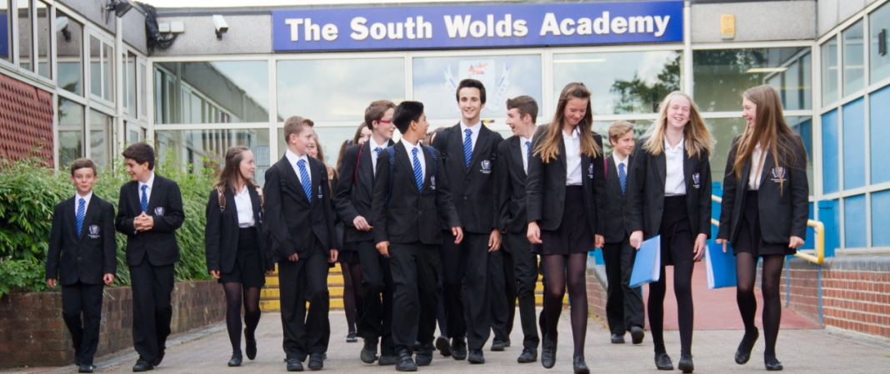

THE SOUTH WOLDS ACADEMY & SIXTH FORM

Church Drive, Keyworth, Nottingham NG12 5FF
Head Teacher: Halina Angus

South Wolds is a high attaining, semi-rural, popular school located in the village of Keyworth in Nottinghamshire which is a 10 minute drive from West Bridgford. . We are also a founding partner of the East Midlands Education Trust, committed to providing a first class education for all of our students.

Relief Handy Person
Scale 2 £9.55 - £9.74 per hour

An immediate vacancy exists for a relief handyperson to assist the Site Manager in the maintenance, operation and security of the school site. The successful applicant will be required to work on a morning/afternoon shift pattern which changes weekly.

South Wolds is committed to safeguarding and promoting the welfare of children and young people and expects all staff and volunteers to share this commitment.
If you would like further details please e-mail vacancies@southwolds.notts.sch.uk or visit our website www.emet.academy/vacancies to download an application pack. Alternatively, contact Gail Burrows on 0115 9373506.

