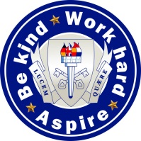

THE SOUTH WOLDS ACADEMY & SIXTH FORM

Church Drive, Keyworth, Nottingham NG12 5FF
Head Teacher: Halina Angus

The South Wolds Academy and Sixth Form is a high attaining, semi-rural, popular school located in the village of Keyworth in Nottinghamshire which is a 10 minute drive from West Bridgford. We are also a founding partner of the East Midlands Education Trust, committed to providing a first class education for all of our students.

Relief Evening Lettings Worker
Scale 2 £9.55 - £9.74 per hour

Due to the school opening up availability for lettings in the community, an immediate vacancy exists for a relief lettings workerto assist the Site Manager in the setting up, monitoring, clearing up of lettings and locking up at the end of the evening. Other general tidying duties maybe included as required by the Site Manager. The successful applicant will need to available to work evening shifts (between 6:45pm and 9:45pm) as required. The exact evenings and hours required will be dependent on the bookings taken.

South Wolds is committed to safeguarding and promoting the welfare of children and young people and expects all staff and volunteers to share this commitment.
If you would like further details please e-mail office@southwolds.notts.sch.uk or visit our website www.emet.academy/vacancies to download an application pack. Alternatively, contact Gail Burrows on 0115 9373506.

Closing date: 21st August at 10am

