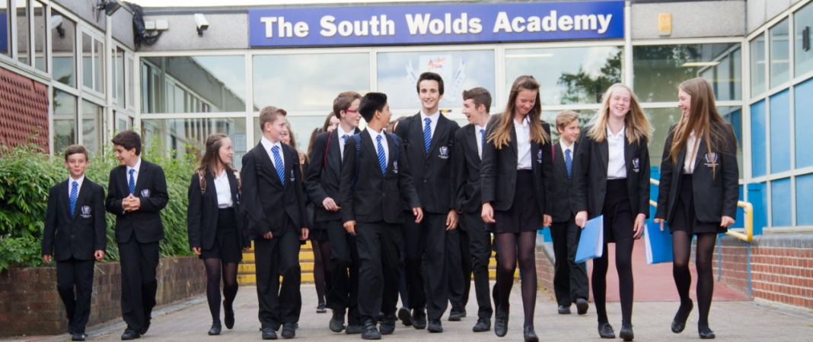

THE SOUTH WOLDS ACADEMY & SIXTH FORM

Church Drive, Keyworth, Nottingham NG12 5FF
Head Teacher: Halina Angus

South Wolds is a high attaining, semi-rural popular school located in the village of Keyworth in Nottinghamshire which is only 6 miles from West Bridgford. We are also a founding partner of the East Midlands Education Trust, committed to providing a first class education for all of our students.

Exam Invigilator
£9.99 per hour
We are looking to add to our bank of exam invigilators to supervise students taking both mock and external exams throughout the school year. You would be employed on an hourly casual basis and contacted prior to the exam period to discuss your own availability.

Although no formal qualifications are required, we are looking for responsible applicants who can follow precise instructions and deal with our students in a calm manner. Full training will be provided.

South Wolds is committed to safeguarding and promoting the welfare of children and young people and expects all staff and volunteers to share this commitment.
If you would like further details please e-mail vacancies@southwolds.notts.sch.uk or visit our website www.southwolds.co.uk to download an application pack. Alternatively, contact Gail Burrows, Office Manager on 0115 9373506.

Closing date for receipt of applications: 9.00 am on Friday 25th October

