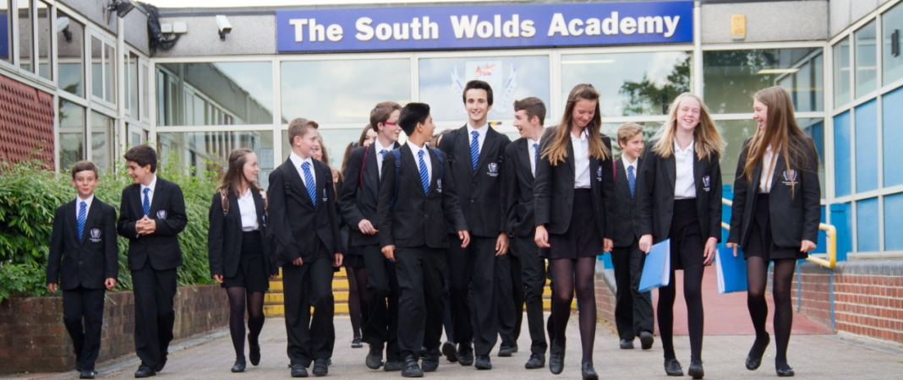

THE SOUTH WOLDS ACADEMY & SIXTH FORM

Church Drive, Keyworth, Nottingham NG12 5FF
Head Teacher: Halina Angus

South Wolds is a high attaining, semi-rural popular school located in the village of Keyworth in Nottinghamshire which is only 6 miles from West Bridgford. We are also a founding partner of the East Midlands Education Trust, committed to providing a first class education for all of our students.

Housekeeper
30.25 hours per week, All Year Round
Scale 1 (£17,364 - £18,065)

We are looking to recruit a Housekeeper to join our small Housekeeping Team. Hours of work will be:
- During Term Time: Currently 12.15pm to 6.30pm Monday to Thursday, and 12.15pm to 5.30pm on Friday
- During School Holidays: 8am to 2.15pm

The post will suit a motivated and flexible team player. Previous cleaning experience is desirable but not essential.

South Wolds is committed to safeguarding and promoting the welfare of children and young people and expects all staff and volunteers to share this commitment.
If you would like further details please e-mail vacancies@southwolds.notts.sch.uk or visit our website www.southwolds.co.uk to download an application pack. Alternatively, contact Gail Burrows, Office Manager on 0115 9373506.

Closing date for receipt of applications: 9.00 am on Friday 22nd November 2019

