Castle Donington College
Receptionist
Scale 2 (£19,264 - £19,650 pro rata)
Full Time, 37 hrs/week (8.00 to 4.00pm Mon-Thurs and 8.00-3.30pm Friday)
39 weeks (term time only)
Commencing: Autumn Term 2022
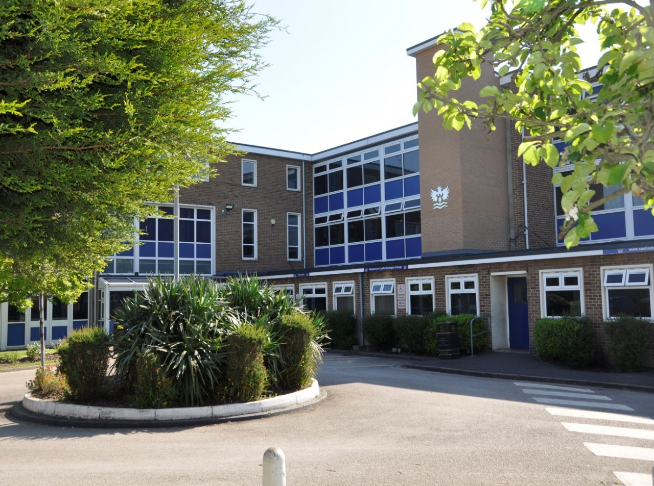

Applicant Information Pack

Receptionist
Dear Applicant,

Thank you for your interest in the post of Receptionist at Castle Donington College. I hope the enclosed pack will be of interest to you and I look forward to receiving your completed application. This is a non-teaching role, based at the College. We welcome applications from people currently working in educational settings and/or with a focus on school administration and those with Reception experience.

Castle Donington College is a small 11-16 school. In September 2021 we expect around 620 students on role across five year groups (Year 7 to 11). The College is situated on the North West edge of Leicestershire on the Leicestershire, Derbyshire, and Nottinghamshire border and within 30 minutes’ drive of Nottingham, Derby, Leicester, Loughborough and Burton, being close to the M1 and A50.

We believe we have the makings of an outstanding school. In January 2019 we received an Ofsted rating of ‘Good’ and continue to strive for excellence in all things. You can be a part of our future.

We are very proud of our community and the students we serve. We are looking for a receptionist to join our office/admin team. We consider this to be a key role at the College a front-line role working with pupils, parents, staff and visitors. The post holder’s main responsibilities will be as the first point of contact for visitors and callers to the school, providing a welcoming and efficient service; and to undertake basic clerical duties in a professional manner to support the smooth running of the general office.
The successful candidate will also play a role in the administration functions across the College. They will be expected to undertake training as required to ensure they are suitably qualified for the role.
All our staff have high expectations of themselves and the students. They work closely to share best practice and drive school improvement. In a recent staff survey 100% of respondents said that Castle Donington College was a good place to work. We are committed to a happy, purposeful and secure environment that provides the opportunity for all to grow and develop. Our staff are highly valued, well regarded and fully supported. We can offer a coherent programme of induction and we have a strong commitment to professional development. We are happy to support training and hand over activities to ensure confidence for the role. Your development will be a key priority for us, regardless of your experience.

The advertised post comes with challenges and requires someone with resilience, drive and ambition. However, we believe that for a candidate with passion for the responsibilities associated with this post, the rewards will be great. We welcome and encourage prospective candidates to come and visit (if Covid 19 control measures allow) to meet our staff and students and to experience the ethos and values of the College.

Yours faithfully,

Julie Sheppard
Principal

Castle Donington College Ethos and Values
At Castle Donington College, we are concerned, first and foremost with people. The staff and Governors are committed to delivering the best possible experience for all of our students. We care passionately about the quality of education we provide.
We consider strong values to be important and so aim to provide individual care and attention for each child and to create a stimulating environment so that effective teaching and learning can take place. Castle Donington College has the highest expectations of its students both academically and socially.
What students can expect from us:

- A challenging inclusive curriculum
- A wide range of curriculum activities
- Good and outstanding teaching everyday
- Targeted and timely support and intervention
- Outstanding pastoral care
- The highest expectations without exception
- Values rooted in respect, kindness, trust and support
- A safe learning environment free from disruption
- To be well prepared for next stage in education, training or employment and for adult life
- That staff have a good understanding of pupils’ strengths and weaknesses and help them to overcome barriers

What we expect from students:

- Excellent attitude to learning, everyday
- A relentless desire to achieve in all areas
- Excellent attendance
- Impeccable conduct every day
- Curiosity and resilience
- To capitalise on advice and feedback in order to improve
- The highest aspirations for the future
- To play and active role in the College community
- Resilience and confidence to succeed

Receptionist – Personal Specification

Qualifications
Level 2 qualifications in maths/numeracy and English/literacy. | E
Able to demonstrate numeracy/literacy skills sufficient for the demands of the post | E
A levels or degree qualification | D
Right to work in the UK | E
Possess or willingness to train for the First Aid at Work or Emergency First Aid at Work qualification | E
Knowledge
Computer literate and have a high level working knowledge of applications including Microsoft Word and Excel | E
Specific and up to date knowledge of UK GDPR appropriate to an educational setting | D
Knowledge of child protection procedures | E
Knowledge of statutory expectations in secondary academy | E
Previous working knowledge of SIM’s and FMS database or similar applications | D
Knowledge of basic health and safety procedures | E
Commitment to, Equal Opportunities, and the ability to apply this to strategic work and day-to-day situations. | E
Experience
Experience in Receptionist role or other relevant post | D
Previous experience of working within a secondary education setting | D
Ability to communicate with a wide range of audiences, including pupils, staff and parents. | E
Experience of responding to members of the public in a work setting | E
Experience of completing clerical tasks | E
Skills
Able to demonstrate positive relationships and effective outcomes all members of the College community | E
A high degree of emotional literacy; a positive outlook whilst maintaining a consistent, no-nonsense approach | E
Ability to use standard office equipment | E
Able to work without supervision, organise workload and demonstrate autonomy, initiative and creativity | E
Excellent organisational skills, efficiency and willingness to respond positively to changing circumstances | E
Ability to run and produce accurate and up-to-date records and reports as required | E
Good customer service and interpersonal skills. | E
Good telephone manner | E
Personal Attributes
Commitment to own professional development | E
Work in ways that promote equal opportunities | E
Self-awareness, empathy, ability to manage feelings, motivation and social skills | E
Strong communication, planning, organisational and time management skills | E
High expectations for accountability and consistency | E
Belief in the potential of individuals | E
Ability to work independently and as part of a team | E
Innovative thinking and solution driven, displaying confidence and independence to work using own initiative | E

Receptionist -Job Description
Job Title | Receptionist | Reporting to: | Office Manager
Department | Support Staff: Administration | Line Managing | -
Contract: | 37 hours per week /39 weeks term time + training days | Normal working day: | 8.00 to 4.00pm Mon-Thurs and 8.00-3.30pm Friday

Safer Recruitment Statement
Castle Donington College is committed to safeguarding and promoting the welfare of pupils and young people and expects all staff and volunteers to share this commitment. This post is designated as a Regulated Activity and the post holder will be subject to an enhanced DBS disclosure check.

Responsibilities of all Support Staff
- To make the education, safety and happiness of the students in the College your primary purpose
- To ensure the need to safeguard students’ well-being is understood and followed in accordance with statutory provisions and in line with College procedures
- To promote the College aims values and ethos and to abide by policies and procedures in all situations
- To maintain high standards of punctuality and attendance
- To act as a role model by demonstrating a professional level of dress, appearance and behaviour
- To treat all members of the College community (staff, students, parents, Governors and visitors) with respect and dignity and at all times observe proper boundaries
- To know and always act within the statutory frameworks which set out your professional duties and responsibilities
- To show a tolerance of and respect for the rights and beliefs of others. To ensure that personal beliefs are not expressed in ways which exploit students’ vulnerability or might lead them to break the law and do not undermine fundamental British values, including democracy, the rule of law, individual liberty and mutual respect and tolerance of those with different faiths and beliefs
- To participate and engage fully in relevant college-based meetings and training activities, within contracted hours, including the appraisal process
- To respond speedily and appropriately to parental concerns, as appropriate to the role

Responsibilities of a Receptionist at Castle Donington College
To support the College by providing administrative support and an efficient and courteous Reception Service.
To operate a Reception Service which promotes a professional image of the College. Duties include
- To provide a courteous reception service, resolving routine queries or calling an appropriate person to respond.
- To ensure that visitors to the school site sign in, provide suitable ID including child protection documentation where applicable, are issued with a visitor pass and are taken to / collected by the appropriate person.
- To answer the telephone and deal with routine queries where possible, or otherwise transfer calls or take and pass on messages.
- To make routine telephone calls to pass on or obtain simple information.
- To undertake post duties, including collecting, opening, sorting and distributing incoming post, and enveloping and dispatching outgoing post.
- To distribute information / documentation to the school community as appropriate, including use of school-home communication systems.
- To respond to routine correspondence by making use of standardised information.
- To assist with arranging meetings by booking rooms and arranging refreshments as instructed.
- To operate standard office equipment, e.g. photocopiers, scanners, shredders, etc.
- To undertake routine typing and word-processing tasks, using standard templates.
- To liaise with staff for the delivery and collection of parcels.
- To assist with the production of pupil lists for activities, clubs, etc. as required.
- To check documents for completeness in preparation for data entry and attempt to resolve routine queries.
- To undertake straightforward data entry onto computer systems.
- To present a positive face of the College and represent the College
- To ensure signing in and out procedure is undertaken and accurate records are kept
- To issue relevant visitors badges in line with the College safeguarding procedures
- To support student queries during the school day, ensuring appropriate response
- Ensure that face to face enquiries (visitors, students and staff) are dealt with appropriately
- To support and administer First Aid and maintain training as required
- Collation of survey information as requested
- To undertake word processing of documentation for example, letters, reports, memos including collation for documentation packs as required
- To occasionally receive cash/cheque payments and pass on to the appropriate person for processing.
- To assist with the day to day general administration, such as filing and checking documents for errors, resolving queries and inputting of straightforward data on computer systems
- To assist with enquiries regarding bookings and lettings as required
- Any other duties, commensurate with the grade, for which the post holder has appropriate skills / training, as may be required from time to time.

This job description sets out the duties and responsibilities of the job at the time when it was drawn up. Such duties and responsibilities may vary from time to time without changing the general character of the duties or the level of responsibility entailed. Such variations are a common occurrence and cannot in themselves justify a reconsideration of the grading of the job. This job description is current at the date shown, but following consultation with you, may be changed by the Principal to reflect or anticipate changes in the job which are commensurate with the salary and job title.
Reviewed July 2022

How to apply

Appointment of | Receptionist
Start date | Autumn Term 2022
Closing date | 8th August 2022
Interview date | tbc

To apply;
- Complete the application form and attach a letter of application, no more than two sides of A4, which sets out your experience to date and what you feel you can contribute to the post. Ensure that your letter of application includes information about your current expertise and experience.

- Email the application form and letter to: recruitment@emet.uk.com

If you are shortlisted you will be contacted by email or letter with further details prior to interview.

Castle Donington College is committed to safeguarding and promoting the welfare of pupils and young people and expects all staff and volunteers to share this commitment. This post is designated as a Regulated Activity and the post holder will be subject to an enhanced DBS disclosure check.

Please be aware, as the applicant, you are responsible for ensuring your application reaches us before the deadline/closing date. Late applications will not be accepted.

