Castle Donington College
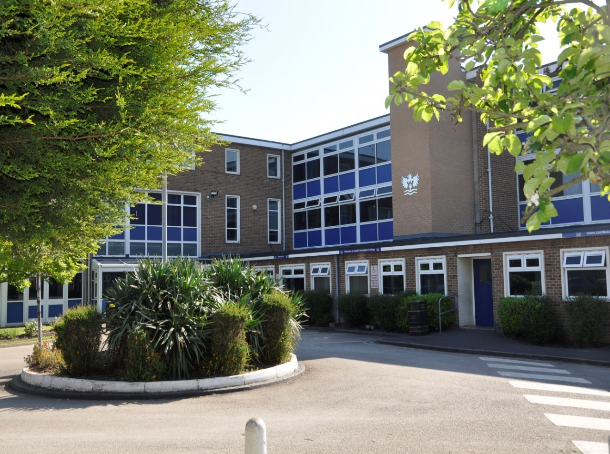
Pastoral Manager
(A non- teaching post)
Grade 5

38 weeks, Term Time only (38 weeks +1 weeks) 37 hours per week
Pro rata Scale 5 pt. 13 – 17 (£23023 - £24920)
Commencing: Autumn Term 2022

Applicant Information Pack
June 2022

Pastoral Manager
Dear Applicant,

Thank you for your interest in the post of Pastoral Manager at Castle Donington College. I hope the enclosed pack will be of interest to you and I look forward to receiving your completed application. This is a non-teaching role, based at the College. We welcome applications from people currently working in educational settings and/or with a focus on supporting young people to fulfil potential and achieve success.

Castle Donington College is a small 11-16 school. In September 2022, we expect 650 pupils on role across five year groups (Year 7 to 11). The College is situated on the North West edge of Leicestershire on the Leicestershire, Derbyshire, and Nottinghamshire border and within 30 minutes’ drive of Nottingham, Derby, Leicester, Loughborough and Burton, being close to the M1 and A50.

We believe we have the makings of a great school. In January 2019 we received an Ofsted rating of ‘Good’ and continue to strive for excellence in all things. You can be a part of our future.

We are very proud of our community and the students we serve. We are looking for a non-teaching Pastoral Manager to join our staff. This is a key role within the Pastoral Team that has undergone significant change. The impact of the successful candidate will be evident through the support pupils receive to ensure they are happy in College and able to learn. The post holder’s main responsibilities will incorporate the following broad areas.
- Supporting Pupils to achieve success day to day
- Pastoral Care
- Liaising with external agencies to support of pupils and families

The successful candidate will play a key role in the day to day success of the College, as an integral member of the Pastoral team, working closely with Principal, College Leaders, Wellbeing leader and Attendance Officer. This is a unique and important role in a busy College. They will be highly organised, efficient and trustworthy, effectively supporting pupils, teachers within the College. They will ensure that the pupil experience is at the heart of everything they do.
All our staff have high expectations of themselves and of the students. They work closely to share best practice and drive school improvement. In a recent staff survey 100% of respondents said that Castle Donington College was a good place to work. We are committed to a happy, purposeful and secure environment that provides the opportunity for all to grow and develop. Our staff are highly valued, well regarded and fully supported. We can offer a coherent programme of induction/ hand over and we have a strong commitment to professional development. We are happy to support training and hand over activities to ensure confidence for the role.

The advertised post comes with challenges and requires someone with resilience, drive and ambition. However, we believe that for a candidate with passion for the responsibilities associated with this post, the rewards will be great. We welcome and encourage prospective candidates to come and visit, to meet our staff and students and to experience first- hand the ethos and values of the College.

Yours faithfully,

Julie Sheppard
Principal

Castle Donington College Ethos and Values
At Castle Donington College, we are concerned, first and foremost with people. The staff and Governors are committed to delivering the best possible experience for all of our students. We care passionately about the quality of education we provide. We consider strong values to be important and so aim to provide individual care and attention for each child and to create a stimulating environment so that effective teaching and learning can take place. Castle Donington College has the highest expectations of its students both academically and socially.
What staff can expect from us
- An open, inclusive and welcoming culture
- A pleasant working environment
- Support and development relevant to the post
- Investment in staff wellbeing
- Responsibility and opportunity
- Professional Development
- Personal challenge and growth appropriate to the role
What we expect from staff:
- Commitment, hard work and reliability
- To contribute fully to day to day successes
- Desire to improve the College for all
- Promote the ethos, values and culture of the College
- Genuine enjoyment of working with young people
What we expect from students:
- Excellent attitude to learning, everyday
- A relentless desire to achieve in all areas
- Excellent attendance
- Impeccable conduct every day
- Curiosity and resilience
- To capitalise on advice and feedback in order to improve
- The highest aspirations for the future
- To play and active role in the College community
- Resilience and confidence to succeed
What students can expect from us:
- A challenging inclusive curriculum
- A wide range of curriculum activities
- Good and outstanding teaching everyday
- Targeted and timely support and intervention
- Outstanding pastoral care
- The highest expectations without exception
- Values rooted in respect, kindness, trust and support
- A safe learning environment free from disruption
- To be well prepared for next stage in education, training or employment and for adult life
- That staff have a good understanding of pupils’ strengths and weaknesses and help them to overcome barriers

Job Description: Pastoral Manager
Job Title | Pastoral Manager | Reporting to: | SLT
Department | Support Staff: Pastoral Team | Salary | Scale 5 pt. 13-17 pro rata (£23023-£24920)
Contract: | 37 hours per week /38 weeks term time + 1 wk/year

Castle Donington College is committed to creating a diverse workforce. We will consider all qualified applicants for employment without regard to sex, race, religion, belief, sexual orientation, gender reassignment, pregnancy, maternity, age, disability, marriage or civil partnership.

Safer Recruitment Statement
Castle Donington College is committed to safeguarding and promoting the welfare of pupils and young people and expects all staff and volunteers to share this commitment. This post is designated as a Regulated Activity and the post holder will be subject to an enhanced DBS disclosure check.

Responsibilities of all Support Staff
- To make the education, safety and happiness of the students in the College your primary purpose
- To ensure the need to safeguard students’ well-being is understood and followed in accordance with statutory provisions and in line with College procedures
- To promote the College aims values and ethos and to abide by policies and procedures in all situations
- To maintain high standards of punctuality and attendance
- To act as a role model by demonstrating a professional level of dress, appearance and behaviour
- To treat all members of the College community (staff, students, parents, Governors and visitors) with respect and dignity and at all times observe proper boundaries
- To know and always act within the statutory frameworks which set out your professional duties and responsibilities
- To show a tolerance of and respect for the rights and beliefs of others. To ensure that personal beliefs are not expressed in ways which exploit students’ vulnerability or might lead them to break the law and do not undermine fundamental British values, including democracy, the rule of law, individual liberty and mutual respect and tolerance of those with different faiths and beliefs
- To participate and engage fully in relevant college-based meetings and training activities, within contracted hours, including the appraisal process
- To respond speedily and appropriately to parental concerns, as appropriate to the role

Responsibilities of a Pastoral Manager at Castle Donington College
Main purpose
To enable all pupils to engage in education by providing leadership and support around welfare, safeguarding, behavioural and attendance issues. This will involve working with staff, parents/carers and pupils to address barriers to learning and make sure effective policies and procedures are in place.
Duties And Responsibilities
Working With Pupils
- Identify strategies to help overcome individual pupils’ barriers to learning
- Use systems to monitor the behaviour and progress of pupils who are on targeted interventions
- Co-ordinate the development of pupils’ individual support plans and review ongoing progress towards set goals
- Manage the transition of new pupils arriving or existing pupils returning to school, putting the necessary support in place to overcome any barriers to learning
- Promote high standards of behaviour and consistently implement the school’s behaviour policy
- To support SLT, the Pastoral Team and Form Tutors by both counselling and disciplining pupils as and when appropriate
- To work closely with SLT, the Pastoral Team, Form Tutors and SENCO to identify students who require specialist behavioural intervention
- To work with the Pastoral Team to provide specialist advice to staff in relation to behaviour targets and the use and effectiveness of individual behaviour plans
Working With Staff
- Make sure each member of staff has access to, understands and can apply consistently, information to support strategies that remove barriers to learning and achievement for identified pupils.
- Liaise with teaching staff to support monitoring activities on individual pupils’ behaviour and attendance
- Work with the attendance officer to monitor and implement strategies to improve the attendance of pupils who are on targeted interventions
- Work with the wider pastoral team to identify pupils in need of additional support and to develop individual support plans
- Work with Senior Leaders to develop whole-school pastoral care strategies, policies and action plans
- Participate in Pastoral meetings, as required
Working With Parents/Carers and External Agencies
- Be a point of contact for parents/carers in relation to pastoral, safeguarding, attendance and behavioural issues, involving relevant staff members as necessary
- Communicate with parents/carers following behavioural incidents to discuss the effectiveness of the support in place for their child
- Maintain regular contact with parents/carers to discuss their child’s progress, behaviour and attendance
- Build positive relations with parents/carers to encourage family involvement in their child’s progress
- Communicate with parents/carers about specific support in place for their child
- Assist parents/carers with any information they need to support their child
- Liaise with external support agencies and professionals as required, to cater for pupils’ individual needs
- Build and refresh knowledge on the range of external support available that could support pupils’ individual needs
Administration
- To monitor rewards and celebrate successes of key students
- To work with the Pastoral Team to monitor and evaluate the standards of behaviour using relevant data
- Maintain accurate records of interventions and relevant meetings
- Facilitate the transfer of relevant pupil information inside and outside the school
- Make sure that pupil information is updated and that staff are aware of the individual needs of pupils
- Complete relevant paperwork required by external agencies
Safeguarding
- Work in line with statutory safeguarding guidance (e.g. Keeping Children Safe in Education, Prevent) and our safeguarding and child protection policies
- Undertake relevant training and work with the designated safeguarding lead (DSL) and Safeguarding Team to promote the best interests of pupils, including sharing concerns where necessary
- Log and respond to safeguarding incidents as appropriate
- Promote the safeguarding of all pupils in the school
This job description sets out the duties and responsibilities of the job at the time when it was drawn up. Such duties and responsibilities may vary from time to time without changing the general character of the duties or the level of responsibility entailed. Such variations are a common occurrence and cannot in themselves justify a reconsideration of the grading of the job. This job description is current at the date shown, but following consultation with you, may be changed by the Principal to reflect or anticipate changes in the job which are commensurate with the salary and job title.
June 2022
Pastoral Manager: Person Specification
Qualifications
Level 2 qualifications in maths/numeracy and English/literacy. | E
Able to demonstrate numeracy/literacy skills sufficient for the demands of the post | E
A levels or degree qualification | D
Right to work in the UK | E
Possess or willingness to train for the First Aid at Work or Emergency First Aid at Work qualification | E
Qualified or willingness to undertake safeguarding training | E
Knowledge
Computer literate and have a good working knowledge of applications including Microsoft Word and Excel | E
Specific and up to date knowledge of UK GDPR appropriate to an educational setting | D
Knowledge of child protection procedures | E
Knowledge of statutory expectations in a secondary school | E
Previous working knowledge of Go4Schools and CPoMs data bases or similar | D
Commitment to, Equal Opportunities, and the ability to apply this to strategic work and day-to-day situations. | E
Experience
Experience of working effectively with young people | E
Experience of pastoral care | D
Previous experience of working within a secondary education setting | D
Ability to communicate with a wide range of audiences, including pupils, staff and parents. | E
Experience of responding to members of the public in a work setting | E
Experience of completing administration tasks | E
Skills
Able to demonstrate positive relationships and effective outcomes all members of the College community | E
Ability to get the best out of young people facing adversity | E
Able to work without supervision, organise workload and demonstrate autonomy, initiative and creativity | E
Excellent organisational skills, efficiency and willingness to respond positively to changing circumstances | E
Ability to run and produce accurate and up-to-date records and reports as required | E
Excellent communication, customer service and interpersonal skills. | E
Excellent attention to detail and able to work through a task to a satisfactory conclusion | E
Personal Attributes
Patient, kind and empathetic | E
A high degree of emotional literacy; a positive outlook whilst maintaining a consistent, no-nonsense approach | E
Child centred | E
Commitment to own professional development | E
Work in ways that promote equal opportunities | E
Self-awareness, empathy, ability to manage feelings, motivation and social skills | E
Strong communication, planning, organisational and time management skills | E
High expectations for accountability and consistency | E
Belief in the potential of individuals | E
Ability to work independently and as part of a team | E
Innovative thinking and solution driven, displaying confidence and independence to work using own initiative | E

How to apply

Appointment of | Pastoral Manager
Start date | Autumn Term 2022
Closing date | Mid-day 29th June 2022

To apply:
- Complete the application form and attach a letter of application, no more than two sides of A4, which sets out your experience to date and what you feel you can contribute to the post. Ensure that your letter of application includes your current expertise, experience and your values and vision for the post.
2. Email your application form to recruitment@emet.uk.com
If you are shortlisted, you will be contacted by email or letter with further details prior to interview.
Please be aware, as the applicant, you are responsible for ensuring your application reaches us before the deadline/closing date. Late applications will not be accepted.

Please be aware, as the applicant, you are responsible for ensuring your application reaches us before the deadline/closing date. Late applications will not be accepted.

Castle Donington College is committed to creating a diverse workforce. We will consider all qualified applicants for employment without regard to sex, race, religion, belief, sexual orientation, gender reassignment, pregnancy, maternity, age, disability, marriage or civil partnership.

Safer Recruitment Statement
Castle Donington College is committed to safeguarding and promoting the welfare of students and young people and expects all staff and volunteers to share this commitment. This post is designated as a Regulated Activity and the post holder will be subject to an enhanced DBS disclosure check.
Mount Pleasant, Castle Donington, Derby, DE74 2LN
T: 01332 810528 Email: postroom@cdcollege.uk

