Castle Donington College
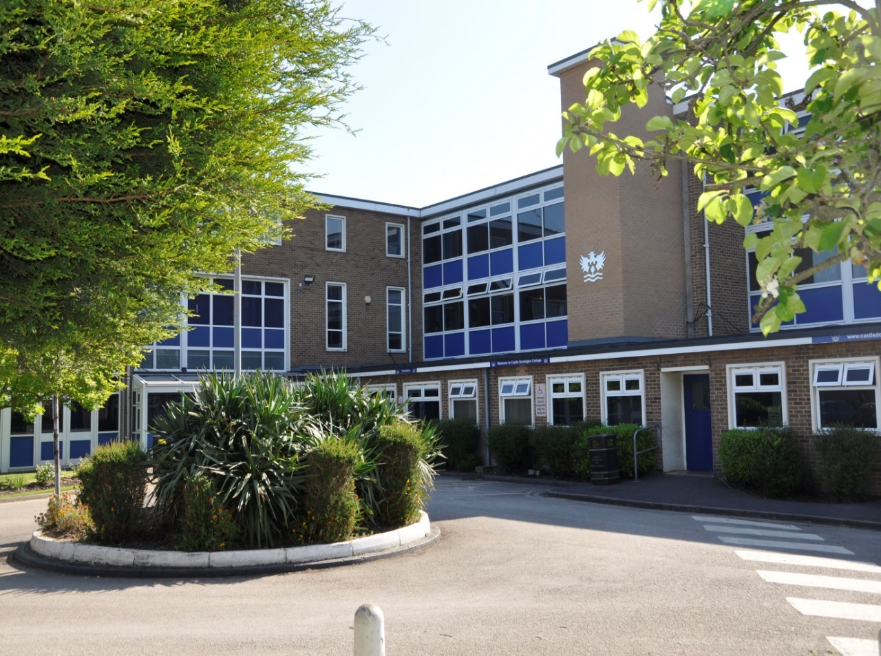
Personal Assistant
(A non- teaching post)
Grade 5

40 weeks, Term Time only (38 weeks +2 weeks) 37 hours per week
Pro rata Scale 5 pt. 13 – 17 (£23023 - £24920)
Commencing: Autumn Term 2022

Applicant Information Pack
May 2022

Personal Assistant to the Principal
Dear Applicant,

Thank you for your interest in the post of Personal Assistant at Castle Donington College. I hope the enclosed pack will be of interest to you and I look forward to receiving your completed application. This is a non-teaching role, based at the College. We welcome applications from people currently working in educational settings and/or with a focus on school administration, communication and record keeping.

Castle Donington College is a small 11-16 school. In September 2021, we had around 630 students on role across five year groups (Year 7 to 11). The College is situated on the North West edge of Leicestershire on the Leicestershire, Derbyshire, and Nottinghamshire border and within 30 minutes’ drive of Nottingham, Derby, Leicester, Loughborough and Burton, being close to the M1 and A50.

We believe we have the makings of a great school. In January 2019 we received an Ofsted rating of ‘Good’ and continue to strive for excellence in all things. You can be a part of our future.

We are very proud of our community and the students we serve. We are looking for a non-teaching Personal Assistant to join our staff. This is a key role supporting the Principal and Senior Team at the College. The impact of the successful candidate will be evident through the smooth running of day-to-day activities and contribution to the public face of the College as a member of the Support Staff Team. The post holder’s main responsibilities will incorporate the following broad areas.
- Administrative support for the Principal and Senior Team
- HR Administration
- Diary Management
- Administration of logs including confidential material
- Communication
- Pupil Admissions
The successful candidate will play a key role in the day to day success of the College, working closely with Principal the Trust Central team and College Leaders. This is a unique and important role in a busy College. Working with the Principal, they will be highly organised, efficient and trustworthy, effectively supporting the development of the College, teachers and other colleagues. They will ensure that the pupil experience is at the heart of everything they do
All our staff have high expectations of themselves and of the students. They work closely to share best practice and drive school improvement. In a recent staff survey 100% of respondents said that Castle Donington College was a good place to work. We are committed to a happy, purposeful and secure environment that provides the opportunity for all to grow and develop. Our staff are highly valued, well regarded and fully supported. We can offer a coherent programme of induction/ hand over and we have a strong commitment to professional development. We are happy to support training and hand over activities to ensure confidence for the role.

The advertised post comes with challenges and requires someone with resilience, drive and ambition. However, we believe that for a candidate with passion for the responsibilities associated with this post, the rewards will be great. We welcome and encourage prospective candidates to come and visit, to meet our staff and students and to experience first- hand the ethos and values of the College.

Yours faithfully,

Julie Sheppard
Principal

Castle Donington College Ethos and Values
At Castle Donington College, we are concerned, first and foremost with people. The staff and Governors are committed to delivering the best possible experience for all of our students. We care passionately about the quality of education we provide. We consider strong values to be important and so aim to provide individual care and attention for each child and to create a stimulating environment so that effective teaching and learning can take place. Castle Donington College has the highest expectations of its students both academically and socially.
What staff can expect from us
- An open, inclusive and welcoming culture
- A pleasant working environment
- Support and development relevant to the post
- Investment in staff wellbeing
- Responsibility and opportunity
- Professional Development
- Personal challenge and growth appropriate to the role
What we expect from staff:
- Commitment, hard work and reliability
- To contribute fully to day to day successes
- Desire to improve the College for all
- Promote the ethos, values and culture of the College
- Genuine enjoyment of working with young people
What we expect from students:
- Excellent attitude to learning, everyday
- A relentless desire to achieve in all areas
- Excellent attendance
- Impeccable conduct every day
- Curiosity and resilience
- To capitalise on advice and feedback in order to improve
- The highest aspirations for the future
- To play and active role in the College community
- Resilience and confidence to succeed
What students can expect from us:
- A challenging inclusive curriculum
- A wide range of curriculum activities
- Good and outstanding teaching everyday
- Targeted and timely support and intervention
- Outstanding pastoral care
- The highest expectations without exception
- Values rooted in respect, kindness, trust and support
- A safe learning environment free from disruption
- To be well prepared for next stage in education, training or employment and for adult life
- That staff have a good understanding of pupils’ strengths and weaknesses and help them to overcome barriers

Personal Assistant: Job Description

Job Title: | Personal Assistant | Reporting to: | Principal and Leadership Team
Contract | 40 weeks, Term Time only (38 weeks +2 weeks)  37 hours per week | Salary | Pro rata  Scale 5 pt. 13 – 17 (£23023 - £24920)

Castle Donington College is committed to creating a diverse workforce. We will consider all qualified applicants for employment without regard to sex, race, religion, belief, sexual orientation, gender reassignment, pregnancy, maternity, age, disability, marriage or civil partnership.

Safer Recruitment Statement
Castle Donington College is committed to safeguarding and promoting the welfare of students and young people and expects all staff and volunteers to share this commitment. This post is designated as a Regulated Activity and the post holder will be subject to an enhanced DBS disclosure check.

Responsibilities of all Support Staff at Castle Donington College
All Support Staff will:
- Uphold public trust in school leadership and maintain high standards of ethics, behaviour and professional conduct
- Build positive and respectful relationships across the school community
- Serve in the best interests of the school’s pupils
- To have an understanding of and always act within, the statutory frameworks which set out your professional duties and responsibilities.
- Treat all students with dignity, building relationships rooted in mutual respect and at all times observing proper boundaries as appropriate to their professional role within the College
- Having a regard for the need to safeguard students’ well-being in accordance with statutory provisions. To ensure all students are safe at all times.
- Show a tolerance of and respect for the rights and beliefs of others
- Not undermining fundamental British values, including democracy, the rule of law, individual liberty and mutual respect and tolerance of those with different faiths and beliefs
- Ensuring that personal beliefs are not expressed in ways which exploit students’ vulnerability or might lead them to break the law
- To have proper and professional regard for the ethos, policies and practices of the College and maintain high standards in your own attendance and punctuality
- To be accountable for achieving the highest possible standards in work and conduct.
- To act with honesty, integrity and work in the best interests of the students at all times.

Responsibilities And Duties Specific To Personal Assistant
To provide a confidential and personal service to the Principal, carrying out a range of secretarial and administrative tasks and maintaining an efficient running of the Principal’s daily business.
Duties And Responsibilities
- Act as the first point of contact for staff, parents, governors and other stakeholders looking to speak with the Principal
- Undertake all telephone and face-to-face enquiries, relating to the work of the Principal, efficiently and in a professional and supportive manner
- Manage all incoming and outgoing correspondence to and from the Principal’s office to a satisfactory conclusion, including drafting letters and emails, open and respond to mail in order to ensure that an appropriate and timely response is made to all communications. Escalating where necessary to the Principal.
- Manage the school’s email inbox, ensuring the school meets its expected response times and emails for the Principal are acted on
- Manage enquiries and requests, from all stakeholders and external bodies, efficiently, referring where necessary
- Ensure that visitors and callers to the Principal’s office receive an efficient, professional, approachable, and welcoming service, in line with the ethos of the school
- Organise and Assist staff, parents, governors, and other stakeholders with the information and support they need
- Handle all confidential correspondence with discretion
HR Administration
- In liaison with the Principal and Personal Assistant, manage recruitment administration for teaching and support staff in accordance with Trust procedures to ensure that all necessary paperwork is completed within the required national and trust timescales.
- Provide administration support to the Principal for any disciplinary, capability or formal attendance meetings. This includes preparation and distribution of reports, letters and associated paperwork, and minute taking during meetings
- Manage staff absence administration including completion of absence insurance claims, administering return to work interviews, and maintaining the school’s absence data via the SIMS Personnel system
- Manage and maintain records and databases as required by the Principal, including staff records, ensuring that information is up to date, readily accessible, managed in accordance with data protection requirements, and that changes are notified to third parties as required.
- Manage the day-to-day maintenance and accurate recording of all employed staff on the Single Central Register
- Follow the ‘Safer Recruitment’ guidance in the recording of information on the SCR
Administration and Diary Management
- Coordinate the Principal’s diary, making decisions around priorities and ensuring the Principal is suitably briefed
- Working with the Main Office to ensure all communication form Postroom reaches the principal in a timely way
- Support the Principal to manage their workload, advising on priorities where appropriate
- Prepare the Principal for meetings by assembling reports and relevant documents
- Respond to appropriate requests for information from governors or external agencies
- Manage and maintain accurate records in efficient files and online systems
- Support with the coordination of certain school events, under the direction of the Principal
- Complete desktop research for the Principal, analysing findings and providing summaries for the Principal
- Take lead responsibility for specified administrative systems as required by the Principal, including the design and implementation of procedures to ensure that the systems run smoothly and efficiently.
Written Communication
- Interpret Principal’s comments into draft written correspondence to be sent to relevant stakeholders
- Develop written communication that’s professional and upholds the school’s vision and values
- Proof-read outgoing communication to ensure it’s of the highest standard and ensure timely feedback
- Take notes at meetings as required
Pupil Admissions
- Manage the College website ensuring it is updated to reflect instruction for new and mid-term applications.
- Forward the arrangements to the Admissions Body as required
- Manage the administration of all admissions. Ensure that all process all admission forms are processed within 10 school days and formal admissions timescales are strictly adhered too.
- Report to the Principal and Senior Team on matters relating to admissions.
- Respond to and process all mid-term application queries within the College and LA timeframes.
- Provide parents with details about process of appeal as appropriate
- Providing the LA, the names and year groups of all applications and appeal outcomes, so they can offer alternative options
- For Year 7 transfers, rank (and validate) all applications in accordance with your criteria, return the ranked list to the LA, in line with LA timeframe
Other Areas of Responsibility
- Read and follow the relevant school policies
- Undertake training required to develop in the role
- Ensure all duties and responsibilities are undertaken in line with the school’s health and safety policy
- Contribute to the safety of children and young people and protect them from harm
- Provide administrative support for the wider senior leadership team when required
- Maintain a high degree of confidentiality with regard to issues concerning members of staff and pupils. Respond with tact, sensitivity and awareness to pupils and parents in relation to duties undertaken

Please note that this is illustrative of the general nature and level of responsibility of the role. It is not a comprehensive list of all tasks that the Principal will carry out. The postholder may be required to do other duties appropriate to the level of the role.
May 2022

Please note that only applicants who can demonstrate that they can meet the criteria in the person specification are likely to be shortlisted for interview. Applicants should be able to demonstrate how they meet the core criteria relevant to the post:
E= Essential D= Desirable A= Application I= Interview | Criteria Type |  | Identified By
 | E | D | A | I

Experience
Carrying out administrative and secretarial tasks
Dealing with face-to-face and telephone interactions
Working with children or young people
Working and collaborating within a team

Qualifications, Training & CPD
Proven record of CPD in areas relevant to the post.
English and Maths GCSE (or equivalent) at grade C or above.

Knowledge & Skills
Good oral and written communications skills
Ability to respond quickly and effectively to issues that arise
Ability to plan, organise and prioritise to meet deadlines
Ability to produce meeting minutes and documents of a high quality
Ability to use own initiative and take action accordingly
Excellent attention to detail
Ability to use IT packages including word processing, spreadsheets and presentation software
Ability to use relevant office equipment effectively
Ability to build effective working relationships with colleagues
Understanding of data protection and confidentiality

Personal Qualities & Attributes
Commitment to promoting the ethos and values of the school and getting the best outcomes for all pupils
Commitment to acting with integrity, honesty, loyalty and fairness to safeguard the assets, financial probity and reputation of the school
Commitment to a team approach; exchanging ideas and providing support to colleagues where needed
Ability to work under pressure and prioritise effectively
Commitment to maintaining confidentiality at all times
Commitment to safeguarding and equality
Embraces change well
Deals with difficult situations effectively
Patient, flexible and adaptable, meticulous and conscientious
Personal Assistant: Person Specification

How to apply

Appointment of | Personal Assistant
Start date | Autumn Term 2022
Closing date | 09.00 Monday 13th June 2022

To apply:
- Complete the application form and attach a letter of application, no more than two sides of A4, which sets out your experience to date and what you feel you can contribute to the post. Ensure that your letter of application includes your current expertise, experience and your values and vision for the post.
2. Email your application form to recruitment@emet.uk.com
If you are shortlisted, you will be contacted by email or letter with further details prior to interview.
Please be aware, as the applicant, you are responsible for ensuring your application reaches us before the deadline/closing date. Late applications will not be accepted.

Please be aware, as the applicant, you are responsible for ensuring your application reaches us before the deadline/closing date. Late applications will not be accepted.

Castle Donington College is committed to creating a diverse workforce. We will consider all qualified applicants for employment without regard to sex, race, religion, belief, sexual orientation, gender reassignment, pregnancy, maternity, age, disability, marriage or civil partnership.

Safer Recruitment Statement
Castle Donington College is committed to safeguarding and promoting the welfare of students and young people and expects all staff and volunteers to share this commitment. This post is designated as a Regulated Activity and the post holder will be subject to an enhanced DBS disclosure check.
Mount Pleasant, Castle Donington, Derby, DE74 2LN
T: 01332 810528 Email: postroom@cdcollege.uk

