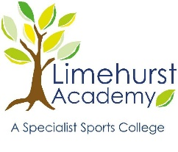
Additional Information for Applicants
At Limehurst Academy, we outsource our IT services to several Primary Schools within the local area.
Detailed below are the systems and software packages which are currently in use both at Limehurst and at the Primary Schools.

Limehurst Academy
Hybrid Cloud model
SCCM Internal
Endpoint Manager Mobile Devices
Hyper-V Cluster – 2 node, 1 shared SAN
HP Switches
Ruckus Wifi
Heavy OneDrive, SharePoint and TEAMS usage.

Primary Schools
Independent Model (not a trust setting)
Unify/Ubiquiti Switches and wireless
Heavy OneDrive, SharePoint and TEAMS usage.

Future plans
Our future plan is for the Academy to drive more towards Endpoint manager for all mobile devices and De-provision SCCM.

